Topic 2
Activity 1

Text 1
- knowledge structure: definition
- graphics: =; symbols; visuals
- content-obligatory vocabulary:
- the language of the knowledge structure:
the language of definition: relating/defining verb; noun phrase (head noun + prepositional phrases + past participle phrase)
- text type: Information Report (Definition)

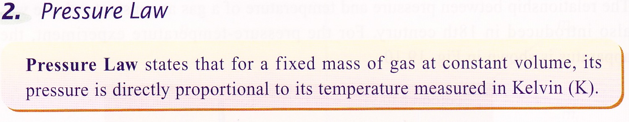

Text 2
- knowledge structures: cause-effect; comparison-contrast
- graphics: arrows, flow chart, table
- content-obligatory vocabulary:
- the language of the knowledge structures:
the language of cause-effect (when-clause; action verbs → causal verbs; causal connective);
the language of comparison-contrast (parallelism; negation; comparative)
- text type: Factorial Explanation within Comparison-contrast (Explanation 1^ Explanation 2)

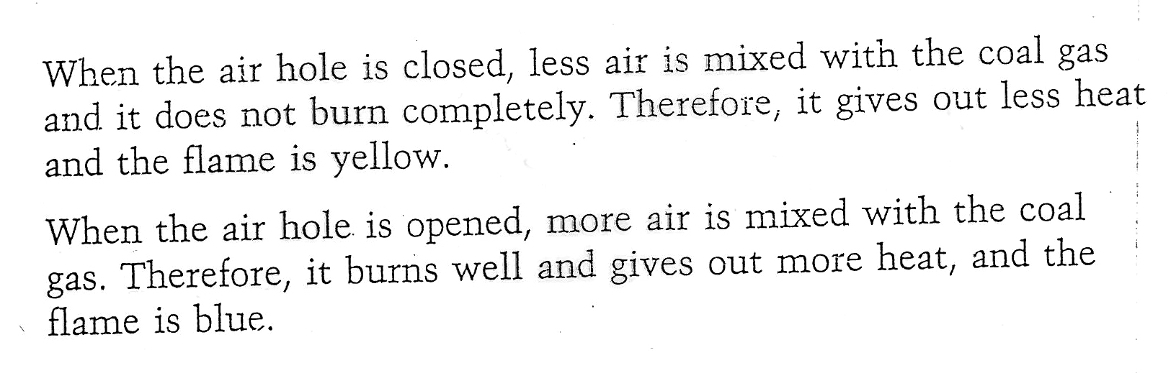

Text 3
- knowledge structures: definition; description; cause-effect
- graphics: =; pictures; arrows
- content-obligatory vocabulary:
- the language of the knowledge structures:
the language of definition: being/relating verb + noun phrase (head noun + prepositional phrases + past participle phrase)
the language of cause-effect: causal verb in passive; causal noun
- text type & structure: Information Report + Factorial Explanation (Definition^ Description^ Phenomenon to explain^ Explanation Sequence)

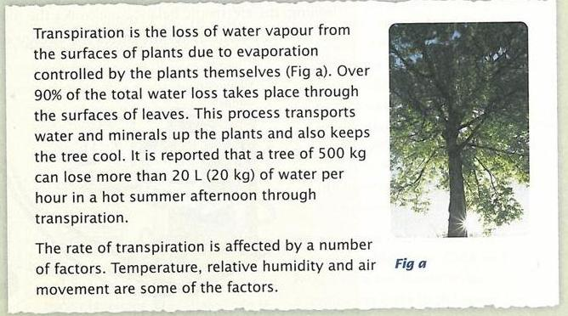

Text 4
- knowledge structures: classification; description
- graphics: tree diagram; table; pictures
- content-obligatory vocabulary:
- the language of the knowledge structure: the language of classification (classifying verbs; class nouns); the language of description (verbs + prepositional phrases)
- text type & structure: Information Report (Classification^ Description)

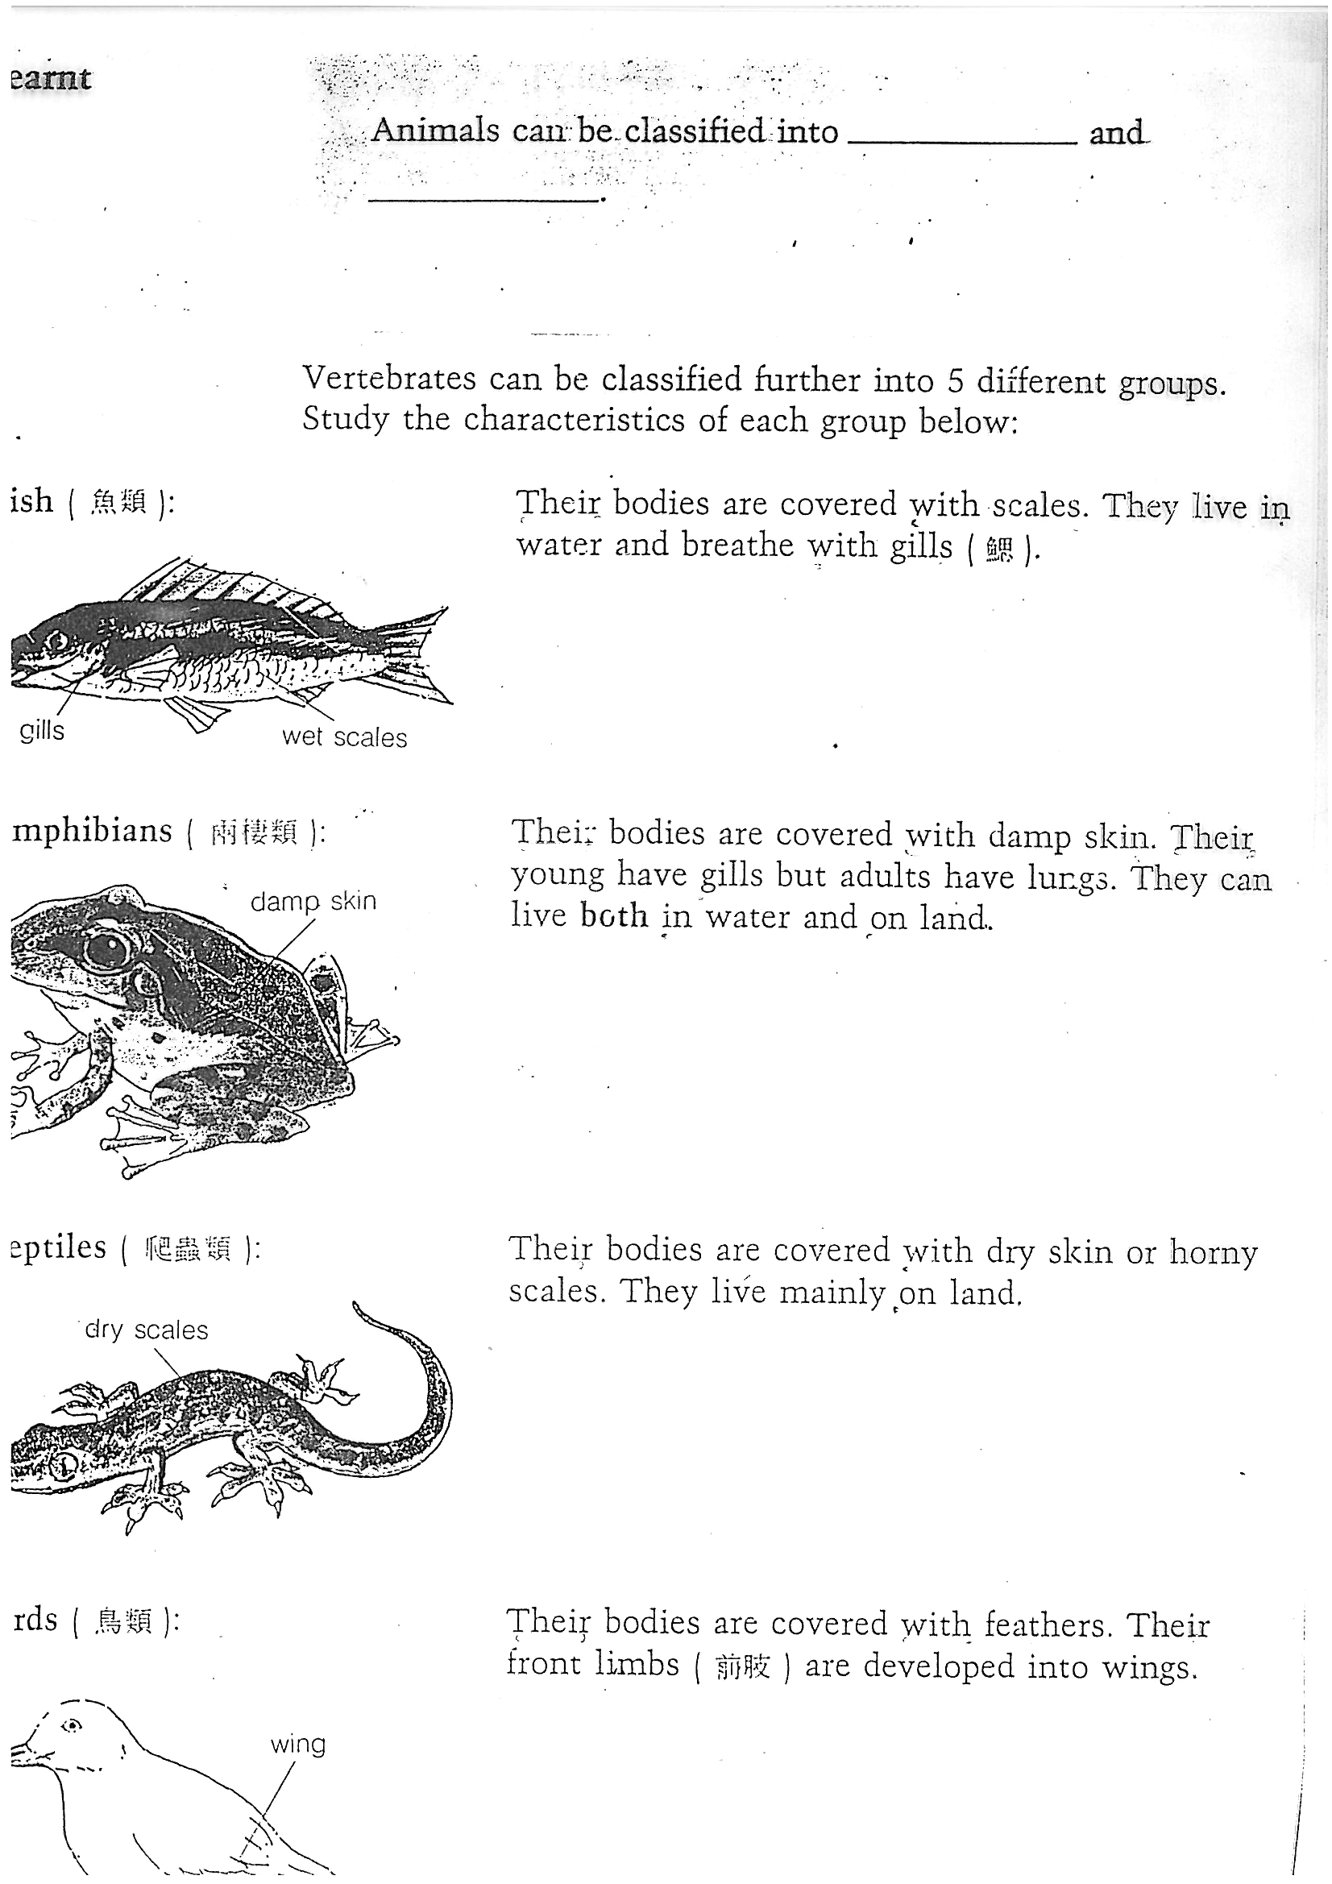
Text 5
- knowledge structure: sequence
- graphics: flow chart; numbering; pictures
- content-obligatory vocabulary:
- the language of the knowledge structure:
the language of instruction: imperatives
the language of information (where, what, how): quantifiers; prepositional phrases
- text type & structure: Procedure (Steps)

2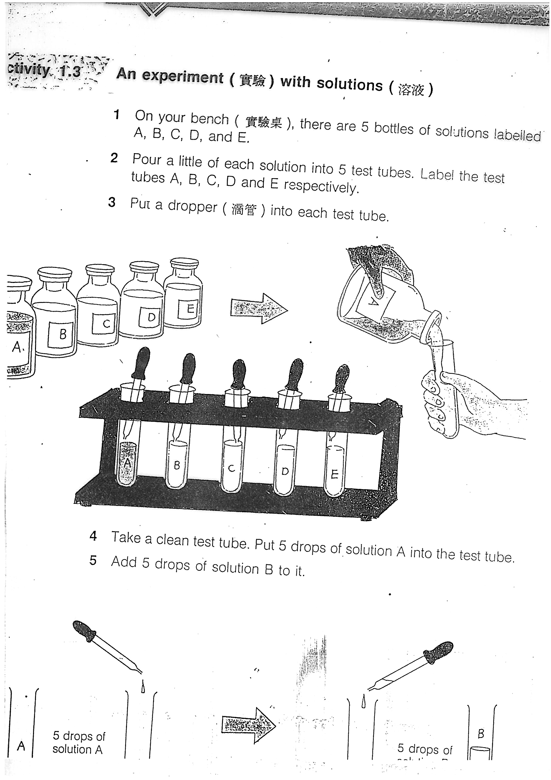

Text 6
- knowledge structures: definition; description; classification; exemplification; comparison-contrast
- graphics: =; table
- content-obligatory vocabulary:
- the language of the knowledge structure:
the language of definition: relating/defining verbs; noun phrases (head noun + relative clause + prepositional phrase + to-infinitive phrase)
the language of classification: classifying verb
the language of description: verbs in passive; prepositional phrases; to-infinitive phrases
the language of exemplification: prepositional phrases
the language of comparison-contrast: parallelism
- text type & structure: Information Report (Definition^ Description 1^ Description 2)

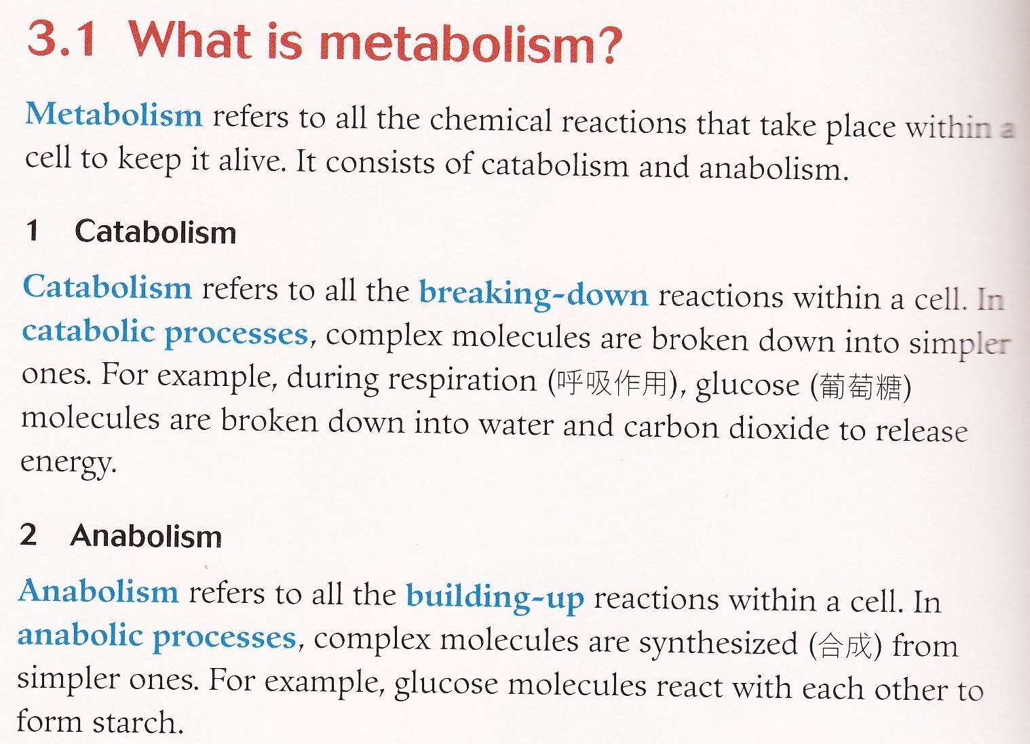

Text 7
- knowledge structure: cause-effect; comparison-contrast
- graphic: arrows; flow chart
- content-obligatory vocabulary:
- the language of the knowledge structure:
the language of cause-effect: causal verbs; causal conjunction, causal connective
the language of comparison-contrast: comparative; prepositional phrase
- text type & structure: Process Explanation (Phenomenon to explain^ Explanation Sequence)

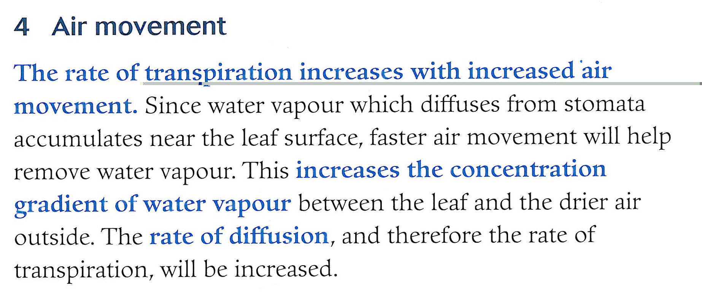
[from Pang & Cheung, 2003, p.29]

Text 8
- knowledge structure: sequence
- graphics: flow chart; table
- content-obligatory vocabulary:
- the language of the knowledge structure:
the language of time sequence: prepositional phrases of time
- text type & structure: Recount (Topic (microscope)^ Events in time order (how microscope helped the discovery of cells))

